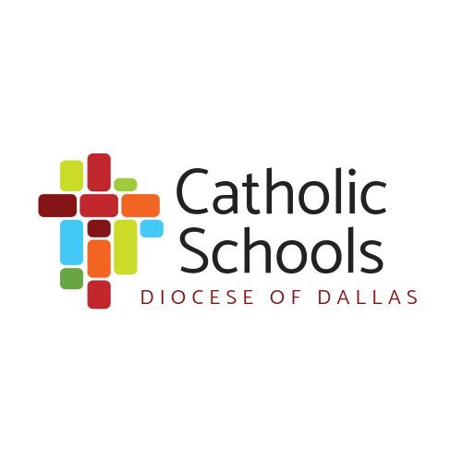
Let’s Collaborate on Schoology!
Welcome to the Catholic Diocese of Dallas schools!
Stay connected with the Catholic School’s Office and your colleagues in our 37 schools with Schoology. Schoology is a web-based Learning Management System where we can collaborate and share resources. Below are the steps to register.
Directions:
- Start at…Schoology.com
- Click “Sign Up” – pull down – click “Student”
- Enter the Group Access code below.
- Enter the Sign-Up information
- Click Course Dashboard
- To add a course, click “join” in the course drop-down menu
- Enter the Course Access code
You are now a member of both a group and a course. In order to stay organized, I will post information and documents from the CSO under “Course”. You can post resources and collaborate with your peers in the “Group”.
 | Group Code | Course Code
Kindergarten | J7BG-859M-GRW9X | NKP3-GS32-B3SZK
1st Grade | 8TQW-7QR8-FHZXJ | 34RX-Z5N5-RMK2G
2nd Grade | S22J-5384-3HDFW | DJCF-G4B4-SZQK4
3rd Grade | WKGX-8PQQ-TTH3F | CHXT-GD8Z-X3XT7
4th Grade | D88P-FFQP-CQVSZ | C3DJ-P9JG-6S7BV
5th Grade | 5HKV-68F3-XGNSH | CVBQ-QGJF-PPJHF
MS Math | PJ5J-RWCC-65MTM | R4NN-28ZR-MPG9J
MS Science | TPF6-NBCB-6BSDT | 5PHS-64Z7-8TVCV
MS Social Studies | VNMR-ZRJW-B7HWP | 2F7J-R342-PQQ4C
MS Language Arts | ZBV9-GP5X-6H4X6 | QH3J-9KHF-3M6CC
MS Religion | QB6X-2WMP-8PR7Q | KKP5-JDGZ-MTW4S
Art | J6TB-ZHD4-S5XCV | KQQ8-Q3K7-PGNHF
Music | 5W6Z-JF8V-HTF5P | 7S8K-6PWX-J4J42
PE | KGFF-XWNK-MG4PV | DHKK-KQNJ-8V6MV
World Languages | 29RM-6FN9-RWC8X | CFRZ-G9PG-29TMN
Library/Media | HNDC-FRM4-FMSPG | ZMHV-7SWG-R5BTD
STEM/Tech/CS/Maker | K4P6-VF8R-MH25F | MTKC-NNNM-2C5NC
Dyslexia Therapists | 3HJ7-NXX3-BSD7F | 2HFF-K843-Q5BBW
PreK | 2VMH-76PR-HQJRG | 8ZHF-BVQ8-42F5Z

Let me know if you have questions: agohsman@cathdal.org. I look forward to working with you.

